Certfee International Institute
(Professional Short courses and Business school)
ISSUES
- We are not able to properly assign courses to an institute
- We are not able to add description of courses
- Change Enroll to ( Enroll Online) and show address phone number for physical course
- Add next course schedule (automatic like flipbz)

HOME PAGE MODIFICATION
Change the look, you can remove the rounded image add a HERO slider
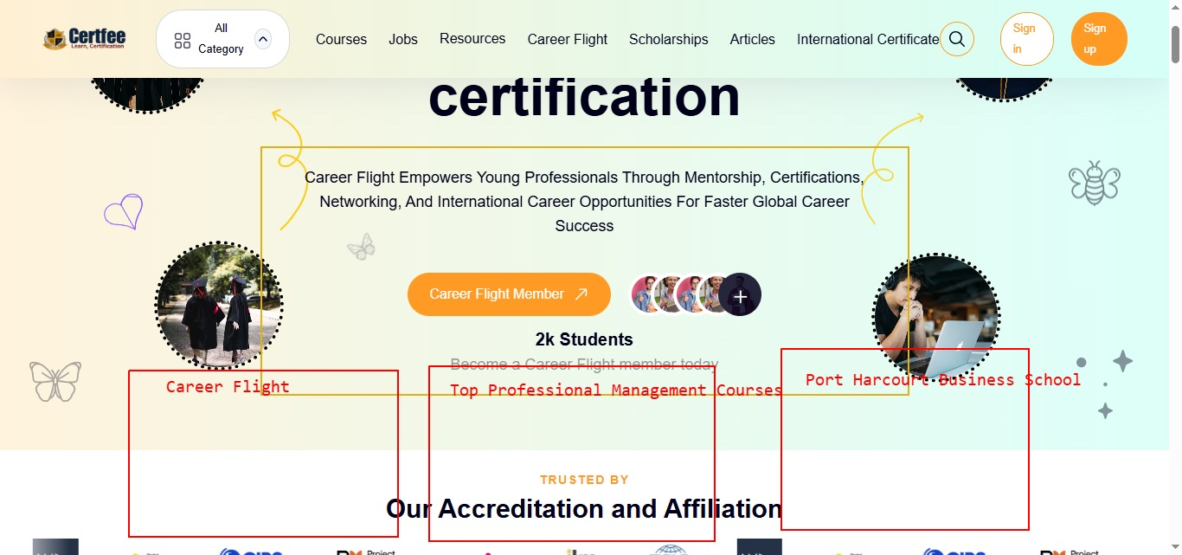

CREATE Institute Dedicated Pages
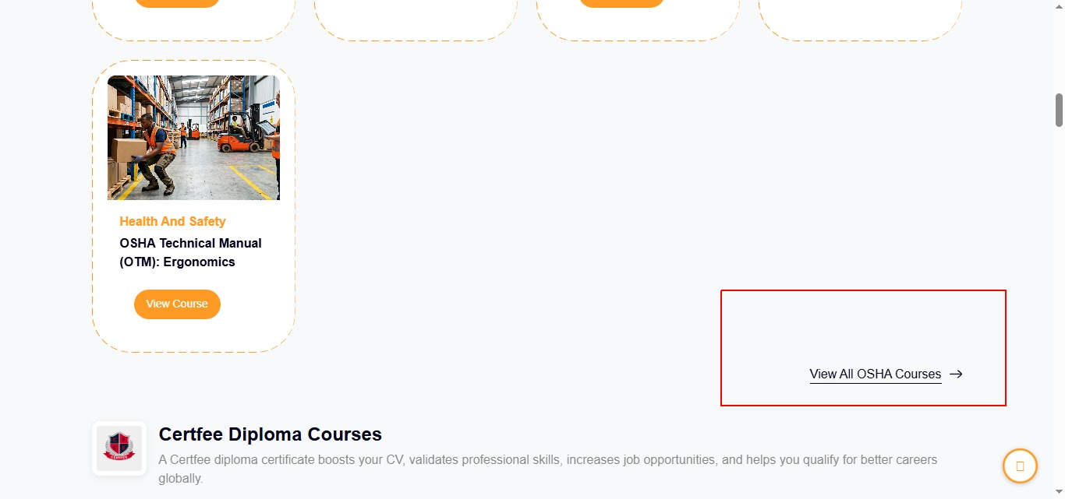

COURSE DETAIL PAGE MORDIFICATION
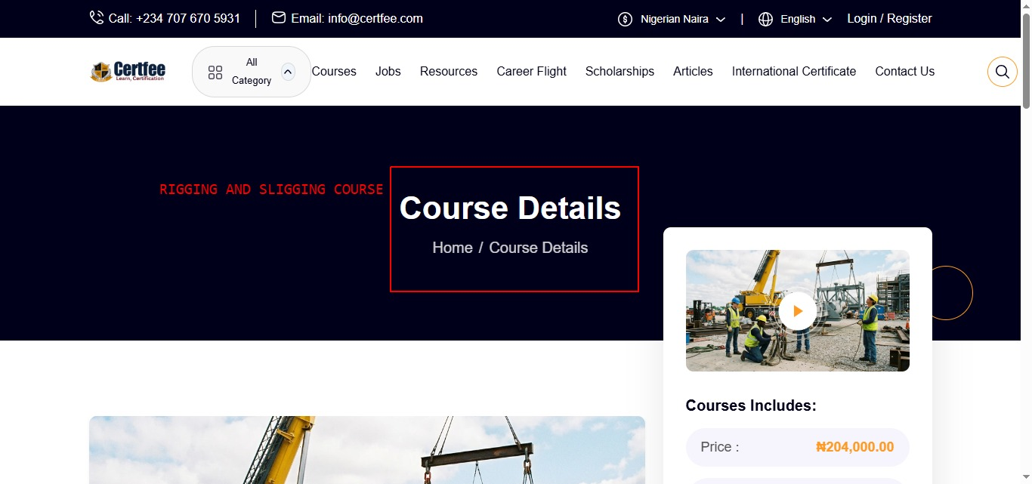

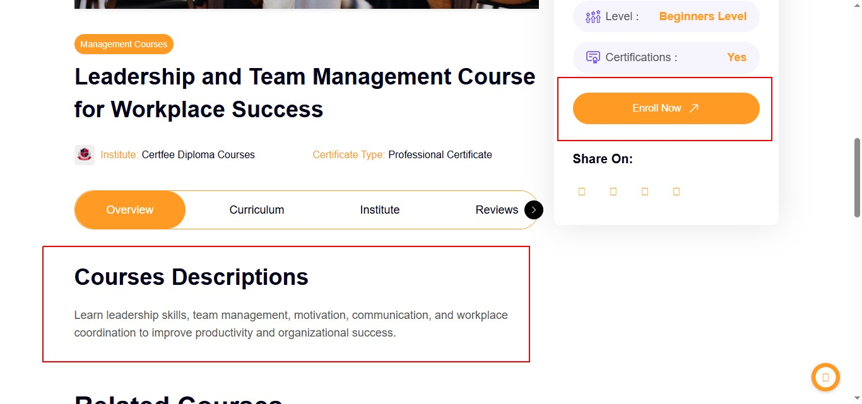

This should be the flow of the content sections ( well demarked by boxes)

- Course upcoming date
- Course Description
- COURSE OBJECTIVES
- Course Outline
- Training Venue
- Certificate type
- FAQ About this course

This should be course outline it’s supposed to be text base
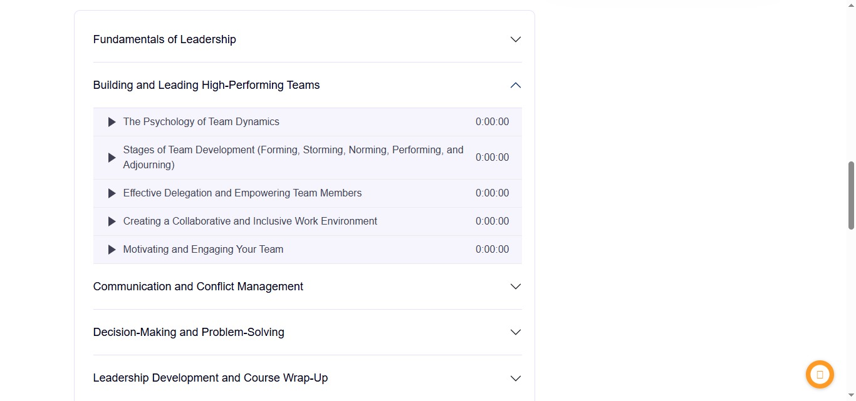

Drastically reduce the course suggestion boxes drastically, reduce into 3 places and put it in a colored background section

- 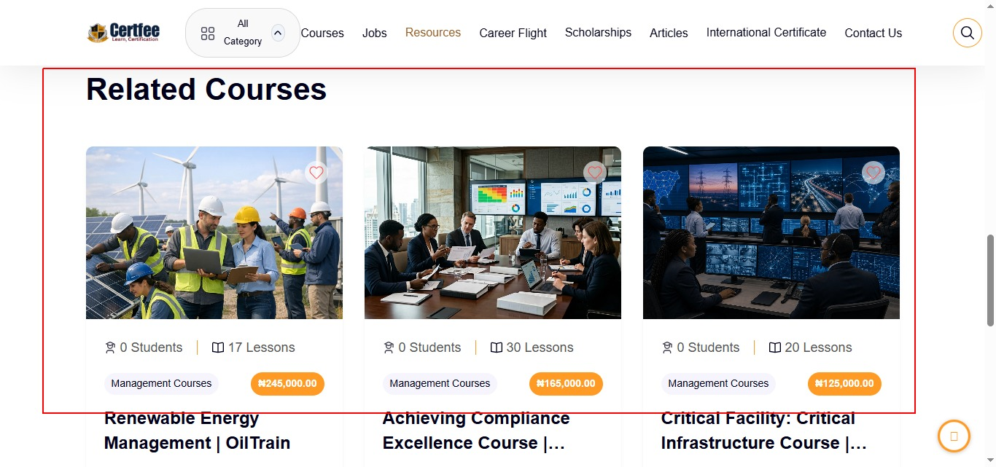

COURSE PAGE
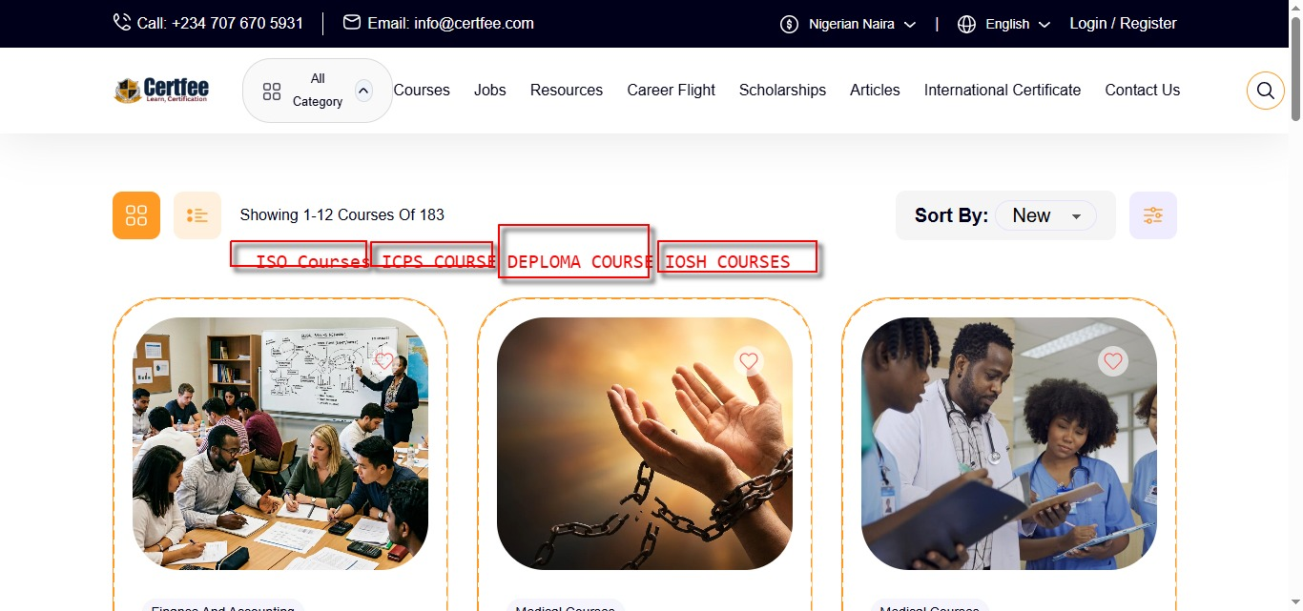
SORT BY INSTITUTE AND COURSE CATEGORIES
- Introductory text area
- More text area
- FAQ at the bottom

Footer
Important courses page on listed on the footer
